1. STUDENT

[CREATE](http://localhost/phpmyadmin/url.php?url=https://dev.mysql.com/doc/refman/5.5/en/create-table.html) [TABLE](http://localhost/phpmyadmin/url.php?url=https://dev.mysql.com/doc/refman/5.5/en/create-table.html) STUDENT (First_Name [VARCHAR](http://localhost/phpmyadmin/url.php?url=https://dev.mysql.com/doc/refman/5.5/en/string-types.html)(10) [NOT](http://localhost/phpmyadmin/url.php?url=https://dev.mysql.com/doc/refman/5.5/en/logical-operators.html#operator_not) NULL, Middle_Name [VARCHAR](http://localhost/phpmyadmin/url.php?url=https://dev.mysql.com/doc/refman/5.5/en/string-types.html)(10) [DEFAULT](http://localhost/phpmyadmin/url.php?url=https://dev.mysql.com/doc/refman/5.5/en/miscellaneous-functions.html#function_default) NULL, Last_Name [VARCHAR](http://localhost/phpmyadmin/url.php?url=https://dev.mysql.com/doc/refman/5.5/en/string-types.html)(10) [NOT](http://localhost/phpmyadmin/url.php?url=https://dev.mysql.com/doc/refman/5.5/en/logical-operators.html#operator_not) NULL, Email_ID [VARCHAR](http://localhost/phpmyadmin/url.php?url=https://dev.mysql.com/doc/refman/5.5/en/string-types.html)(20) [DEFAULT](http://localhost/phpmyadmin/url.php?url=https://dev.mysql.com/doc/refman/5.5/en/miscellaneous-functions.html#function_default) NULL, S_ID [VARCHAR](http://localhost/phpmyadmin/url.php?url=https://dev.mysql.com/doc/refman/5.5/en/string-types.html)(10) PRIMARY KEY, Age [DECIMAL](http://localhost/phpmyadmin/url.php?url=https://dev.mysql.com/doc/refman/5.5/en/numeric-types.html)(2) [NOT](http://localhost/phpmyadmin/url.php?url=https://dev.mysql.com/doc/refman/5.5/en/logical-operators.html#operator_not) NULL, Contact_Number [DECIMAL](http://localhost/phpmyadmin/url.php?url=https://dev.mysql.com/doc/refman/5.5/en/numeric-types.html)(10) [NOT](http://localhost/phpmyadmin/url.php?url=https://dev.mysql.com/doc/refman/5.5/en/logical-operators.html#operator_not) NULL, Event_Name [VARCHAR](http://localhost/phpmyadmin/url.php?url=https://dev.mysql.com/doc/refman/5.5/en/string-types.html)(10), PG_Name [VARCHAR](http://localhost/phpmyadmin/url.php?url=https://dev.mysql.com/doc/refman/5.5/en/string-types.html)(20), Re_Name [VARCHAR](http://localhost/phpmyadmin/url.php?url=https://dev.mysql.com/doc/refman/5.5/en/string-types.html)(10), University_Name [VARCHAR](http://localhost/phpmyadmin/url.php?url=https://dev.mysql.com/doc/refman/5.5/en/string-types.html)(30), Degree [VARCHAR](http://localhost/phpmyadmin/url.php?url=https://dev.mysql.com/doc/refman/5.5/en/string-types.html)(10) [NOT](http://localhost/phpmyadmin/url.php?url=https://dev.mysql.com/doc/refman/5.5/en/logical-operators.html#operator_not) NULL, Branch [VARCHAR](http://localhost/phpmyadmin/url.php?url=https://dev.mysql.com/doc/refman/5.5/en/string-types.html)(10) [NOT](http://localhost/phpmyadmin/url.php?url=https://dev.mysql.com/doc/refman/5.5/en/logical-operators.html#operator_not) NULL, Sem [DECIMAL](http://localhost/phpmyadmin/url.php?url=https://dev.mysql.com/doc/refman/5.5/en/numeric-types.html)(1) [NOT](http://localhost/phpmyadmin/url.php?url=https://dev.mysql.com/doc/refman/5.5/en/logical-operators.html#operator_not) NULL)

[ALTER](http://localhost/phpmyadmin/url.php?url=https://dev.mysql.com/doc/refman/5.5/en/alter-table.html) [TABLE](http://localhost/phpmyadmin/url.php?url=https://dev.mysql.com/doc/refman/5.5/en/alter-table.html) `student` ADD CONSTRAINT `student1` FOREIGN KEY (`Event_Name`) REFERENCES `events` (`Event_Name`)

[ALTER](http://localhost/phpmyadmin/url.php?url=https://dev.mysql.com/doc/refman/5.5/en/alter-table.html) [T)ABLE](http://localhost/phpmyadmin/url.php?url=https://dev.mysql.com/doc/refman/5.5/en/alter-table.html) `student` ADD CONSTRAINT `student2` FOREIGN KEY (`PG_Name`) REFERENCES `pg_hostel` (`PG_Name`

[ALTER](http://localhost/phpmyadmin/url.php?url=https://dev.mysql.com/doc/refman/5.5/en/alter-table.html) [TABLE](http://localhost/phpmyadmin/url.php?url=https://dev.mysql.com/doc/refman/5.5/en/alter-table.html) `student` ADD CONSTRAINT `student3` FOREIGN KEY (`Re_Name`) REFERENCES `resturant` (`Re_Name`)

[ALTER](http://localhost/phpmyadmin/url.php?url=https://dev.mysql.com/doc/refman/5.5/en/alter-table.html) [TABLE](http://localhost/phpmyadmin/url.php?url=https://dev.mysql.com/doc/refman/5.5/en/alter-table.html) `student` ADD CONSTRAINT `student4` FOREIGN KEY (`University_Name`) REFERENCES `university` (`University_Name`)

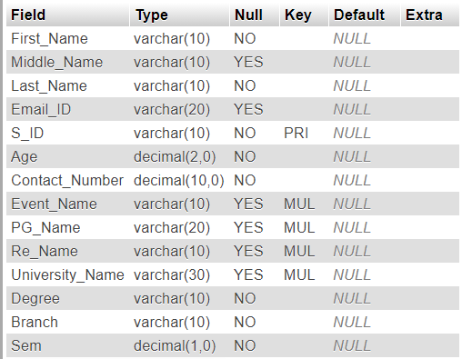

2.Community

CREATE TABLE COMMUNITY (Mentor_Name VARCHAR(25) DEFAULT NULL, Community_Head VARCHAR(25) NOT NULL, Community_Name VARCHAR(25) PRIMARY KEY);

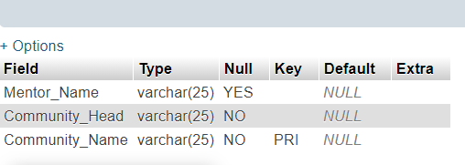

1. STATIONARY

CREATE TABLE STATIONARY (Timmings TIME NOT NULL, Stationary_Name VARCHAR(10) PRIMARY KEY, Stationary_Address VARCHAR(200) NOT NULL);

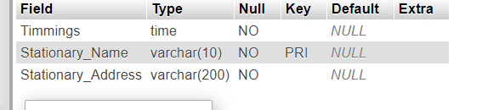

1. EVENT

CREATE TABLE EVENTS(Event_Date_Start TIMESTAMP NOT NULL, Event_Date_End DATETIME NOT NULL, Event_Name VARCHAR(20) PRIMARY KEY, Branch VARCHAR(10) NOT NULL);

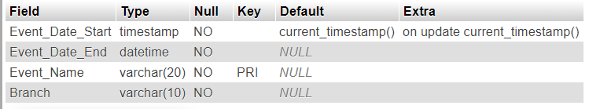

1. BOOK

CREATE TABLE BOOK (Book_Name VARCHAR(10) NOT NULL, Book_ID DECIMAL(5) PRIMARY KEY, Author_Name VARCHAR(20) NOT NULL, Buy_Date DATE NOT NULL, New_Old VARCHAR(5) NOT NULL);

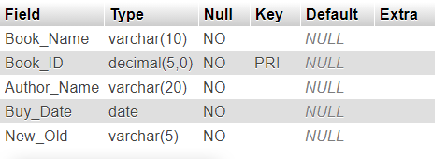

1. PG/HOSTEL

[CREATE](http://localhost/phpmyadmin/url.php?url=https://dev.mysql.com/doc/refman/5.5/en/create-table.html) [TABLE](http://localhost/phpmyadmin/url.php?url=https://dev.mysql.com/doc/refman/5.5/en/create-table.html) PG_HOSTEL (PG_Name [VARCHAR](http://localhost/phpmyadmin/url.php?url=https://dev.mysql.com/doc/refman/5.5/en/string-types.html)(20) PRIMARY KEY, PG_Address [varchar](http://localhost/phpmyadmin/url.php?url=https://dev.mysql.com/doc/refman/5.5/en/string-types.html)(200) [NOT](http://localhost/phpmyadmin/url.php?url=https://dev.mysql.com/doc/refman/5.5/en/logical-operators.html#operator_not) NULL, Room_Number [DECIMAL](http://localhost/phpmyadmin/url.php?url=https://dev.mysql.com/doc/refman/5.5/en/numeric-types.html)(5) [NOT](http://localhost/phpmyadmin/url.php?url=https://dev.mysql.com/doc/refman/5.5/en/logical-operators.html#operator_not) NULL, Owner_Address [VARCHAR](http://localhost/phpmyadmin/url.php?url=https://dev.mysql.com/doc/refman/5.5/en/string-types.html)(200) [DEFAULT](http://localhost/phpmyadmin/url.php?url=https://dev.mysql.com/doc/refman/5.5/en/miscellaneous-functions.html#function_default) NULL, Owner_Contact [DECIMAL](http://localhost/phpmyadmin/url.php?url=https://dev.mysql.com/doc/refman/5.5/en/numeric-types.html)(10) [NOT](http://localhost/phpmyadmin/url.php?url=https://dev.mysql.com/doc/refman/5.5/en/logical-operators.html#operator_not) NULL, Rent [VARCHAR](http://localhost/phpmyadmin/url.php?url=https://dev.mysql.com/doc/refman/5.5/en/string-types.html)(20) [NOT](http://localhost/phpmyadmin/url.php?url=https://dev.mysql.com/doc/refman/5.5/en/logical-operators.html#operator_not) NULL, RO [VARCHAR](http://localhost/phpmyadmin/url.php?url=https://dev.mysql.com/doc/refman/5.5/en/string-types.html)(10) [NOT](http://localhost/phpmyadmin/url.php?url=https://dev.mysql.com/doc/refman/5.5/en/logical-operators.html#operator_not) NULL, TWO_BHK_3BHK [VARCHAR](http://localhost/phpmyadmin/url.php?url=https://dev.mysql.com/doc/refman/5.5/en/string-types.html)(10) [NOT](http://localhost/phpmyadmin/url.php?url=https://dev.mysql.com/doc/refman/5.5/en/logical-operators.html#operator_not) NULL, AC_NONAC [VARCHAR](http://localhost/phpmyadmin/url.php?url=https://dev.mysql.com/doc/refman/5.5/en/string-types.html)(10) [NOT](http://localhost/phpmyadmin/url.php?url=https://dev.mysql.com/doc/refman/5.5/en/logical-operators.html#operator_not) NULL, Freeze [VARCHAR](http://localhost/phpmyadmin/url.php?url=https://dev.mysql.com/doc/refman/5.5/en/string-types.html)(10) [NOT](http://localhost/phpmyadmin/url.php?url=https://dev.mysql.com/doc/refman/5.5/en/logical-operators.html#operator_not) NULL)

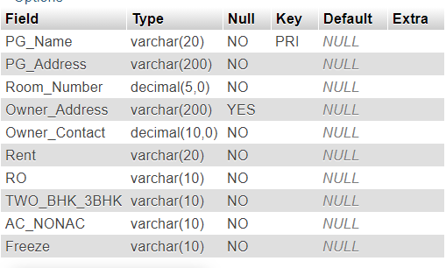

1. Restaurant

CREATE TABLE Resturant (Re_Address VARCHAR(200) NOT NULL, Re_Name VARCHAR(20) PRIMARY KEY, Re_Timing_Start TIME NOT NULL, Re_Timing_End TIME NOT NULL, Star INT NOT NULL, B_L_D VARCHAR(20) NOT NULL);

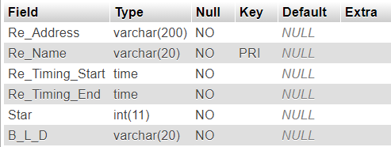

1. ADMIN

[CREATE](http://localhost/phpmyadmin/url.php?url=https://dev.mysql.com/doc/refman/5.5/en/create-table.html) [TABLE](http://localhost/phpmyadmin/url.php?url=https://dev.mysql.com/doc/refman/5.5/en/create-table.html) ADMIN (UserName [VARCHAR](http://localhost/phpmyadmin/url.php?url=https://dev.mysql.com/doc/refman/5.5/en/string-types.html)(20) PRIMARY KEY, [Password](http://localhost/phpmyadmin/url.php?url=https://dev.mysql.com/doc/refman/5.5/en/encryption-functions.html#function_password) [VARCHAR](http://localhost/phpmyadmin/url.php?url=https://dev.mysql.com/doc/refman/5.5/en/string-types.html)(20) [NOT](http://localhost/phpmyadmin/url.php?url=https://dev.mysql.com/doc/refman/5.5/en/logical-operators.html#operator_not) NULL, S_ID [VARCHAR](http://localhost/phpmyadmin/url.php?url=https://dev.mysql.com/doc/refman/5.5/en/string-types.html)(10), PG_Name [VARCHAR](http://localhost/phpmyadmin/url.php?url=https://dev.mysql.com/doc/refman/5.5/en/string-types.html)(20), Re_Name [VARCHAR](http://localhost/phpmyadmin/url.php?url=https://dev.mysql.com/doc/refman/5.5/en/string-types.html)(20), Event_Name [VARCHAR](http://localhost/phpmyadmin/url.php?url=https://dev.mysql.com/doc/refman/5.5/en/string-types.html)(20), University_Name [VARCHAR](http://localhost/phpmyadmin/url.php?url=https://dev.mysql.com/doc/refman/5.5/en/string-types.html)(10), Book_ID [DECIMAL](http://localhost/phpmyadmin/url.php?url=https://dev.mysql.com/doc/refman/5.5/en/numeric-types.html)(5), community_Head [VARCHAR](http://localhost/phpmyadmin/url.php?url=https://dev.mysql.com/doc/refman/5.5/en/string-types.html)(10) [NOT](http://localhost/phpmyadmin/url.php?url=https://dev.mysql.com/doc/refman/5.5/en/logical-operators.html#operator_not) NULL, Acitvity_Name [VARCHAR](http://localhost/phpmyadmin/url.php?url=https://dev.mysql.com/doc/refman/5.5/en/string-types.html)(10) [NOT](http://localhost/phpmyadmin/url.php?url=https://dev.mysql.com/doc/refman/5.5/en/logical-operators.html#operator_not) NULL, stationary_Name [VARCHAR](http://localhost/phpmyadmin/url.php?url=https://dev.mysql.com/doc/refman/5.5/en/string-types.html)(10))

[ALTER](http://localhost/phpmyadmin/url.php?url=https://dev.mysql.com/doc/refman/5.5/en/alter-table.html) [TABLE](http://localhost/phpmyadmin/url.php?url=https://dev.mysql.com/doc/refman/5.5/en/alter-table.html) `admin` ADD CONSTRAINT `amin1213` FOREIGN KEY (`stationary_Name`) REFERENCES `stationary` (`stationary_Name`)

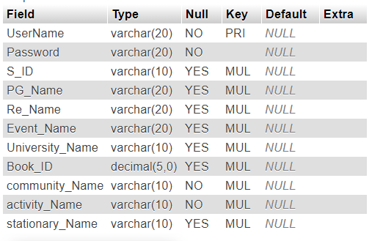

[CREATE](http://localhost/phpmyadmin/url.php?url=https://dev.mysql.com/doc/refman/5.5/en/create-table.html) [table](http://localhost/phpmyadmin/url.php?url=https://dev.mysql.com/doc/refman/5.5/en/create-table.html) ADMIN (UserName [VARCHAR](http://localhost/phpmyadmin/url.php?url=https://dev.mysql.com/doc/refman/5.5/en/string-types.html)(20) PRIMARY KEY, [Password](http://localhost/phpmyadmin/url.php?url=https://dev.mysql.com/doc/refman/5.5/en/encryption-functions.html#function_password) [VARCHAR](http://localhost/phpmyadmin/url.php?url=https://dev.mysql.com/doc/refman/5.5/en/string-types.html)(255))

insert into admin VALUES ('admin1','admin2000');

[UPDATE](http://localhost/phpmyadmin/url.php?url=https://dev.mysql.com/doc/refman/5.5/en/update.html) ADMIN [SET](http://localhost/phpmyadmin/url.php?url=https://dev.mysql.com/doc/refman/5.5/en/set.html) [Password](http://localhost/phpmyadmin/url.php?url=https://dev.mysql.com/doc/refman/5.5/en/encryption-functions.html#function_password) = AES_ENCRYPT([Password](http://localhost/phpmyadmin/url.php?url=https://dev.mysql.com/doc/refman/5.5/en/encryption-functions.html#function_password), 'admin')

[SELECT](http://localhost/phpmyadmin/url.php?url=https://dev.mysql.com/doc/refman/5.5/en/select.html) UserName, AES_DECRYPT([Password](http://localhost/phpmyadmin/url.php?url=https://dev.mysql.com/doc/refman/5.5/en/encryption-functions.html#function_password), 'admin') AS pwd FROM ADMIN

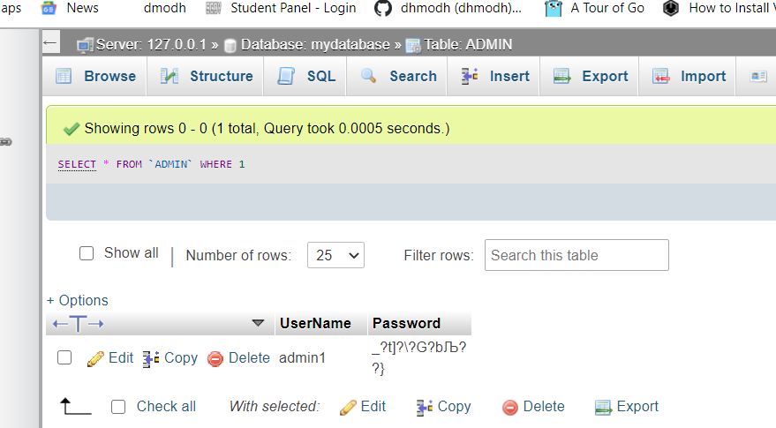

1. Stationay_Buy

[CREATE](http://localhost/phpmyadmin/url.php?url=https://dev.mysql.com/doc/refman/5.5/en/create-table.html) [TABLE](http://localhost/phpmyadmin/url.php?url=https://dev.mysql.com/doc/refman/5.5/en/create-table.html) stationary_Buy (S_ID [VARCHAR](http://localhost/phpmyadmin/url.php?url=https://dev.mysql.com/doc/refman/5.5/en/string-types.html)(10), stationary_Name [VARCHAR](http://localhost/phpmyadmin/url.php?url=https://dev.mysql.com/doc/refman/5.5/en/string-types.html)(10) PRIMARY KEY)

[ALTER](http://localhost/phpmyadmin/url.php?url=https://dev.mysql.com/doc/refman/5.5/en/alter-table.html) [TABLE](http://localhost/phpmyadmin/url.php?url=https://dev.mysql.com/doc/refman/5.5/en/alter-table.html) `stationary_buy` ADD CONSTRAINT `sb` FOREIGN KEY (`S_ID`) REFERENCES `student` (`S_ID`)

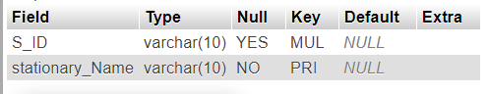

1. Member

[CREATE](http://localhost/phpmyadmin/url.php?url=https://dev.mysql.com/doc/refman/5.5/en/create-table.html) [TABLE](http://localhost/phpmyadmin/url.php?url=https://dev.mysql.com/doc/refman/5.5/en/create-table.html) Member (community_Name [VARCHAR](http://localhost/phpmyadmin/url.php?url=https://dev.mysql.com/doc/refman/5.5/en/string-types.html)(10) PRIMARY KEY, S_ID [VARCHAR](http://localhost/phpmyadmin/url.php?url=https://dev.mysql.com/doc/refman/5.5/en/string-types.html)(10))

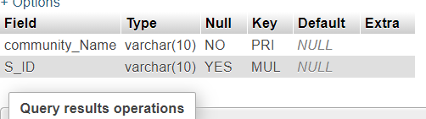

1. University

[CREATE](http://localhost/phpmyadmin/url.php?url=https://dev.mysql.com/doc/refman/5.5/en/create-table.html) [TABLE](http://localhost/phpmyadmin/url.php?url=https://dev.mysql.com/doc/refman/5.5/en/create-table.html) University (University_Name [VARCHAR](http://localhost/phpmyadmin/url.php?url=https://dev.mysql.com/doc/refman/5.5/en/string-types.html)(30) PRIMARY KEY, Location [VARCHAR](http://localhost/phpmyadmin/url.php?url=https://dev.mysql.com/doc/refman/5.5/en/string-types.html)(200) [NOT](http://localhost/phpmyadmin/url.php?url=https://dev.mysql.com/doc/refman/5.5/en/logical-operators.html#operator_not) NULL)

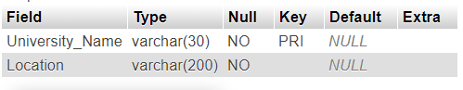

1. Courses

[CREATE](http://localhost/phpmyadmin/url.php?url=https://dev.mysql.com/doc/refman/5.5/en/create-table.html) [TABLE](http://localhost/phpmyadmin/url.php?url=https://dev.mysql.com/doc/refman/5.5/en/create-table.html) Courses (University_Name [VARCHAR](http://localhost/phpmyadmin/url.php?url=https://dev.mysql.com/doc/refman/5.5/en/string-types.html)(30), Courses_Name [VARCHAR](http://localhost/phpmyadmin/url.php?url=https://dev.mysql.com/doc/refman/5.5/en/string-types.html)(10) [NOT](http://localhost/phpmyadmin/url.php?url=https://dev.mysql.com/doc/refman/5.5/en/logical-operators.html#operator_not) NULL)

[ALTER](http://localhost/phpmyadmin/url.php?url=https://dev.mysql.com/doc/refman/5.5/en/alter-table.html) [TABLE](http://localhost/phpmyadmin/url.php?url=https://dev.mysql.com/doc/refman/5.5/en/alter-table.html) `courses` ADD CONSTRAINT `COURSES` FOREIGN KEY (`University_Name`) REFERENCES `university` (`University_Name`)

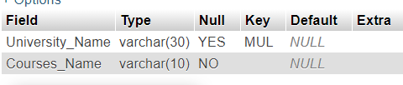

1. Activity

[CREATE](http://localhost/phpmyadmin/url.php?url=https://dev.mysql.com/doc/refman/5.5/en/create-table.html) [TABLE](http://localhost/phpmyadmin/url.php?url=https://dev.mysql.com/doc/refman/5.5/en/create-table.html) Activity (S_ID [VARCHAR](http://localhost/phpmyadmin/url.php?url=https://dev.mysql.com/doc/refman/5.5/en/string-types.html)(10), Activity_Name [VARCHAR](http://localhost/phpmyadmin/url.php?url=https://dev.mysql.com/doc/refman/5.5/en/string-types.html)(10) PRIMARY KEY, Activity_Place [VARCHAR](http://localhost/phpmyadmin/url.php?url=https://dev.mysql.com/doc/refman/5.5/en/string-types.html)(20) [NOT](http://localhost/phpmyadmin/url.php?url=https://dev.mysql.com/doc/refman/5.5/en/logical-operators.html#operator_not) NULL, Instruments [VARCHAR](http://localhost/phpmyadmin/url.php?url=https://dev.mysql.com/doc/refman/5.5/en/string-types.html)(10) [NOT](http://localhost/phpmyadmin/url.php?url=https://dev.mysql.com/doc/refman/5.5/en/logical-operators.html#operator_not) NULL)

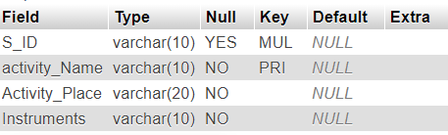

1. Oraganize

[CREATE](http://localhost/phpmyadmin/url.php?url=https://dev.mysql.com/doc/refman/5.5/en/create-table.html) [TABLE](http://localhost/phpmyadmin/url.php?url=https://dev.mysql.com/doc/refman/5.5/en/create-table.html) Oraganize(S_ID [VARCHAR](http://localhost/phpmyadmin/url.php?url=https://dev.mysql.com/doc/refman/5.5/en/string-types.html)(10), Event_Name [VARCHAR](http://localhost/phpmyadmin/url.php?url=https://dev.mysql.com/doc/refman/5.5/en/string-types.html)(10) PRIMARY KEY)

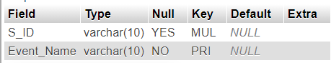

SCHEMA

